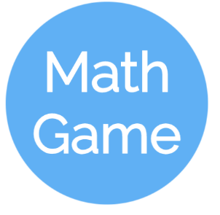 **Technical Feasibility Study for Math Game**

Created by: Group 1

Team Members: Gavin Davy, Michael Erickson, and Rena Sakai

**Purpose**:

The purpose of this questionnaire is to determine the technical and operational feasibility of an educational game application that helps elementary students develop their math skill by practicing “math facts,” i.e. basic addition and subtraction problems that involve two 1-digit numbers.

To that end, this questionnaire addresses issues of hardware and software requirements for such an application, how these requirements affect the usage of the application by its users, how adequate a mobile application is to achieving the aims of this project, and how parental/teacher controls can be implemented, if appropriate.

**Questions**:

1. What hardware is required to run applications developed for Android?
2. Will elementary students have access to hardware capable of running an Android application?
3. Are there any software requirements for running applications developed for Android?
4. Are there any additional technical requirements running the application?
5. Being that the application is being targeted toward elementary-aged students, how can it be constructed/formatted so as to be accessible?
6. Being that the application is being targeted toward elementary-aged students, how can it be constructed/formatted so as to be engaging?
7. Is a mobile/computer application an appropriate medium for achieving the aim of the application?
8. How much content is appropriate for an application of this type?
9. How advanced should the material, i.e. the problems to be solved by the user, be?
10. Would parental/teacher controls be appropriate for the application? If so, what form should they take and how should they be implemented?